

**BS Comuter Sciense I-C (E)**

**Course code CS-101**

ICT LAB MANUAL

**Fall / Spring 2026**

**Tuba Jan**

**CSC-25F-602**

**Course Supervisor**

**Sir Jamal Ahmed Khan**

**Lab Instructor**

**Sir Sunil Kumar**



CERTIFICATE

### Department of Computer Science

This is to certify that Mr/Ms. So/Do having

Roll No. has successfully completed laboratory work during Spring Semester 2025.

**Lab Instructor**

**Sir Sunil**

Signature

**Index**

Table of Contents

Q. Explore MS word environment further and also familiar with tabs other than HOME. 11

ITC LAB TASK 01-02 11

Insert multi-level list 15

Table of Contents 16

LAB TASK 17

Q) Write a report on any topic with proper formatting utilizing MS Word 2013. 17

ITC LAB TASK-03 (Report) 18

COVER PAGE: 19

KEY FUNCTIONS OF A COVER PAGE: 19

Steps to produce Mail Merge: 30

Steps to produce Mail Merge: 31

LAB TASK 34

Q) Develop a work sheet of 10 students in a college with the number of days 34

ITC LAB TASK 05 35

To group rows or columns: 38

To hide and show groups: 39

LAB TASK 39

Q) Every student will develop a mark sheet with his/her details 39

Creating a Database: 41

LAB TASK 44

Q) Create any database with 10 fields maximum in MS Access 2013 44

Presentation PowerPoint 2013: 46

Lab 06 Task: 49

Q: Make a presentation in power point on any suitable topic. 49

Difference between Tables and Form: 51

create a form: 51

Laboratory Experiment 10 52

Student’s task: 54

Laboratory Experiment 11 57

HTML Login , Information Page: 57

Laboratory Experiment 12 61

concepts of table layout designing: 62

Student’s ID: **Laboratory Exercise No: 1 & 2** Student’s Name:

**Objective:** Getting familiarize with basic functions in MS word 2013. **Goal:** In this lab, students will get practical familiarity of M.S word 2013. **Required Equipment:**

### PC.

1. MS word 2013

## Theory:

There are many word processing packages available now a days. Microsoft Word is a most common among them. It can be used to create reports, latter and other documents. It provides facility to use home [computer](http://www.baycongroup.com/wlesson0.htm) as well as business computer for desktop publishing.

## Getting Start:

Microsoft word 2013 can be launched by double clicking this icon. Initially this screen can be seen as shown below:

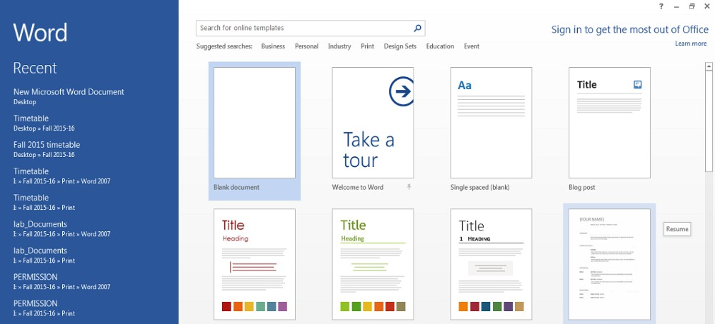

Fig 1.1

This provides facility to open Blank Word document and different word templates in right pane. A history of recently opened word files can be opened as shows in left pane.

When a blank document opens, following program window appear as shown in the fig 1.2

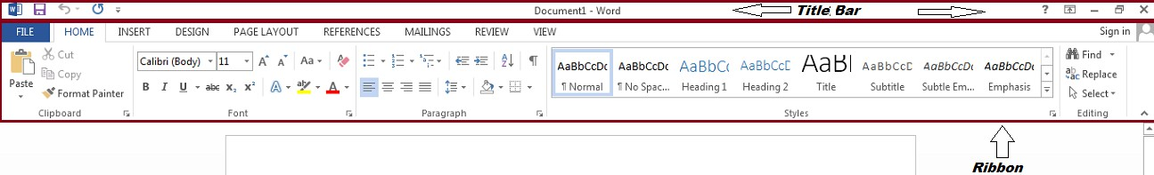

Fig 1.2

M.S Word 2013 user interface comprises two main components named as Title Bar & Ribbon which have following elements as shown in fig 1.3. Title Bar reflects the name of currently active document. It display –Word suffix until document is saved.

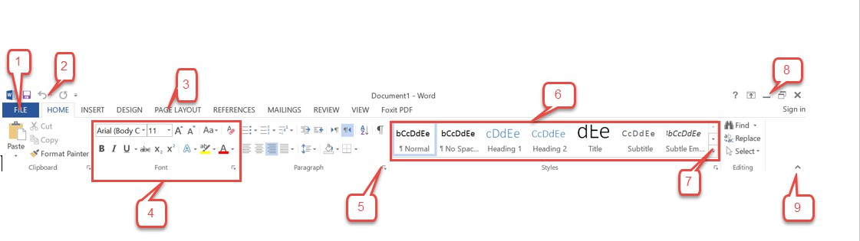

Fig 1.3

1. File tab
2. Quick Access Toolbar
3. Ribbon tab
4. Group
5. Dialog box launcher
6. Gallery
7. More Button
8. Window controls
9. Collapse ribbon

**File tab:** This is another tab on ribbon which has a unique feature. All other tabs have commands which apply on the content of document. This tab brings a view where commands exists for entire document such as Export, Share, Save As, Print, Share and Close.

**Quick Access Toolbar:** This toolbar contain commands which are used frequently, like Redo, Save and Undo.

**Ribbon tab:** All commands which are present on a ribbon are spread under different tabs like HOME, INSERT, DESIGN etc

**Group:** Each Ribbon tab has number of Group. These are the collection (group) of commands having a similar functions. Like "Font" group has commands which are applied on Fonts.

**Dialog box launcher:** It contain more options available for commands. For example dialog box launcher under "Style" group launch a dialog box that contains available options for set of commands related to Style group.

**Gallery:** It is a preview of choices which offer number of depicted formats to choose. It is also list of related tools.

**More Button:** When more commands in a certain Group are available, they are hidden under a line over an arrow pointing downward. Click left mouse button show more commands under relevant Group.

**Window controls:** It has buttons to control MS Word 2013 window like close, maximize and minimize. It also has button to control Ribbon whether Ribbon can be hidden or show with/without tabs.

**Collapse ribbon:** It just hides Ribbon.

**Ribbon Tabs**

There are eight ribbon tabs in MS Word 2013 as follows;

1. Home
2. INSERT
3. DESIGN
4. PAGE LAYOUT
5. REFERENCES
6. MAILINGS
7. REVIEW
8. VIEW

Only first two ribbon tables will be discussed in this laboratory exercise.

**HOME Tab**

This tab is selected by default when a blank document is opened. There are 5 Groups in this tab as shown in fig 1.4



Fig 1.4

**Clipboard Group:** In this tab commands associated with temporary storage area of data for data movement purpose resides such as cut, copy and paste. It also has Format Painter Command which modify the one part of content according to another part of contents.

**Font Group:** This group has commands which are directly applied to shape of contents and other characteristic assosiated with it such as Bold, Italic, Underline, style through, super script (appear a character as exponent) and subsript (appear as base). It also has commands to change font color and Case.

**Paragraph Group:** This group is about presentation of a paragraph and alignment of contents. Whether contents should be right, left and middle alignment with page or it should auto-adjust with page margin. How much space should be allowed between lines and after/before a paragraph. It also provides different commands to create a list and to enclose a paragraph in border to stand it out.

**Styles Group:** This group provides predefined styles of contents based on the commands associated with font and paragraph Group. So it includes character formatting as well as paragraph formatting. Style can be selected, created and modified as well through style group dialog box launcher.

**Editing Group:** As name implies, this group has commands to edit contents of word documents. It provides facility to select, find and replace contents (text and objects such as picture).

**INSERT Tab**

There are ten groups in this Ribbon tab as shown in fig 1.5



Fig 1.5

**Pages Group:** This group has offer commands to add cover and blank page. There is also a command to define active page boundary explicitly by page break command.

**Table Group:** Table can be inserted by providing number of rows and columns or can be drawn manually with this group commands.

**Illustrations Group:** Components which help with illustration like picture, shapes, charts and screen shots can be added by this group.

**APPS Group:** Different sort of applications can be added using this group commands. Applications which are offered by Microsoft office store only can be used.

**Online Video Media Group:** This command can add video from internet.

**Link Group:** Internet based links, book mark and references can be added with this group commands.

**Comments Group:** A note or observation can be added by this command.

**Header and Footer:** Header and footer can be inserted with this group command. Header is specific content which is supposed to appear on the top margin of every page whereas footer is supposed to appear on the bottom margin. There is also a command to add page number as header or footer.

**Text Group:** This Group has commands to add text box, artistic text, date, time and object. It also provides command to add signature line.

**Symbols Group:** Different symbols as well as Equations can be added with this group commands. A special Design tool associated with equation command initiate which offer different types of equations.

**Page Layout Tab**

One formatting aspect we need to consider as we create our document is whether to make adjustments to the **layout of the page**. The page layout affects how content appears and includes the page's **orientation**, **margins**, and **size**.

**Changing Page Orientation:**

1. Select the **Page Layout** tab.
2. 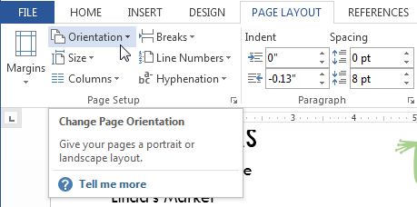Click the **Orientation** command in the Page Setup group.
3. A drop-down menu will appear. Click either **Portrait** or **Landscape** to change the page orientation

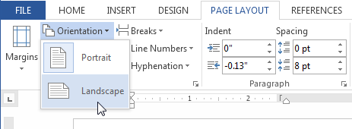

1. The page orientation of the document will be changed.

**Page margins:**

A **margin** is the **space** between the text and the edge of your document. By default, a new document's margins are set to **Normal**, which means it has a one-inch space between the text and each edge. Depending on your needs, Word allows you to change your document's margin size.

**To format page margins:**

Word has a variety of **predefined margin sizes** to choose from.

1. Select the **Page Layout** tab, then click the **Margins** command.

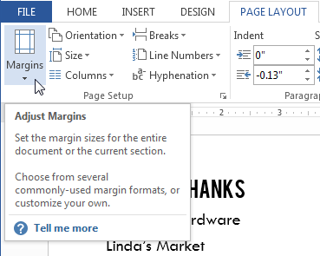

1. 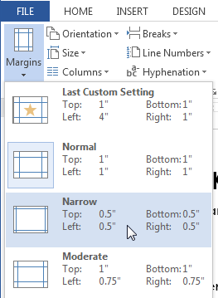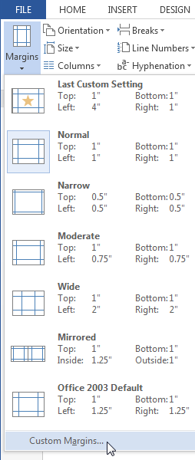A drop-down menu will appear. Click the **predefined margin size** we want
2. The margins of the document will be changed.

**To use custom margins:**

Word also allows you to customize the size of your margins in the **Page Setup** dialog box.

1. From the **Page Layout** tab, click **Margins**. Select **Custom Margins...** from the drop-down menu.
2. The Page Setup dialog box will appear.
3. Adjust the values for each margin, then click **OK**

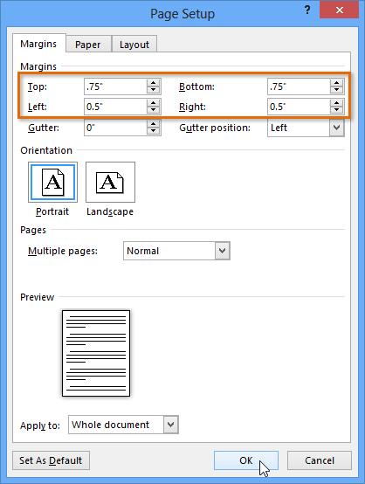

The margins of the document will be changed.

**Page size:** By default, the **page size** of a new document is 8.5 inches by 11 inches. Depending on your project, you may need to adjust your document's page size. It's important to note that before modifying the default page size, you should check to see which page sizes your printer can accommodate.

**To change the page size:**

Word has a variety of **predefined page sizes** to choose from.

1. Select the **Page Layout** tab, then click the **Size** command.

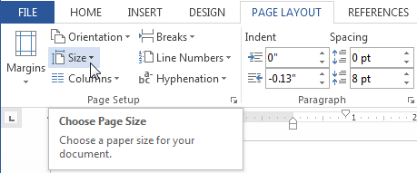

1. A drop-down menu will appear. The current page size is highlighted. Click the desired **predefined page size**.

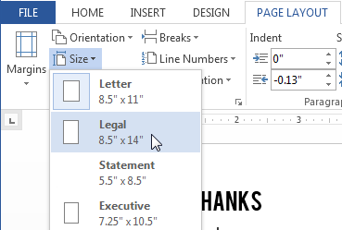

1. The page size of the document will be changed.

**To use a custom page size:** Word also allows you to customize the page size in the **Page Setup** dialog box.

* 1. From the **Page Layout** tab, click **Size**. Select **More Paper Sizes...** from the drop-down menu.

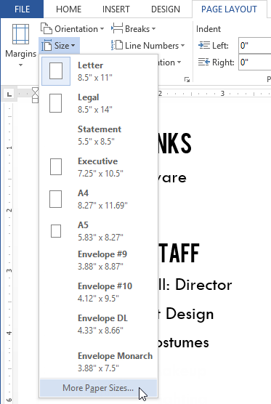

* 1. The Page Setup dialog box will appear.
  2. Adjust the values for **Width** and **Height**, then click **OK**.

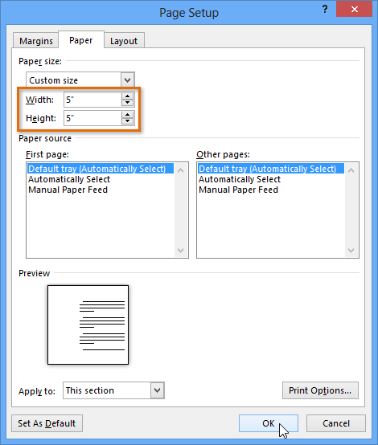

* 1. The page size of the document will be changed.

Alternatively, we can open the Page Setup dialog box by navigating to the Page Layout tab and clicking the small **arrow** in the bottom-right corner of the **Page Setup** group.

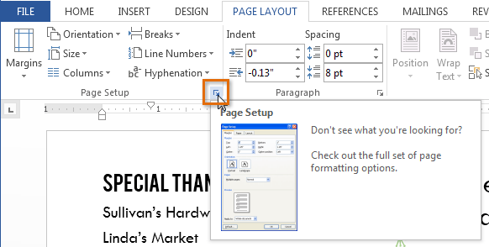

we can use Word's convenient **Set as Default** feature to **save** all of the **formatting** changes you've made and automatically apply them to new documents.

LAB TASK

## Q. Explore MS word environment further and also familiar with tabs other than HOME.

# ITC LAB TASK 01-02

**MS Word :**

MS Word (Microsoft Word) is a word processing program for creating, editing, and formatting documents like letters, reports, and resumes. Developed by Microsoft, it is a key component of the [Microsoft Office suite](https://www.google.com/search?sca_esv=8d3d49c28ce86d19&sxsrf=AE3TifM3BMLpeEisNYemH32BQpfdLtBktA:1760631004418&q=Microsoft+Office+suite&sa=X&sqi=2&ved=2ahUKEwjGg-XMjamQAxUvgP0HHavjNK8QxccNegQIFBAB&mstk=AUtExfBPJB4mZHvFXSici3VQki0GK7ewkOaMhVvKInPSj1aAm9yom9fVUSohgDlVrrSTYEJ4TyCBvdBOLYkV6LOyNZK43FCw9xKdbmmZXxZOJ9MP1V8peUwDv8dlSxRBa0Bqa8ugNr4cIR9erenZI4aNnBJ8n_3Yt5-6dEE848_cAA128oM&csui=3) and includes features such as spell and grammar checking, text formatting, and the ability to insert images, tables, and charts.

**Key Features And Uses**

Document creation:

It allows users to create a wide variety of documents, from simple letters to complex reports and professional resumes.

Editing and formatting:

Word offers extensive tools for formatting text, and users can also apply borders, page colors, and other visual elements.

Collaboration:

Multiple users can work on a document together, with features to track changes and leave comments.

Built-in checks:

The program includes a spell checker and a grammar checker to help ensure documents are error-free.

Multimedia integration:

You can insert images, tables, charts, and even videos into your documents.

Templates:

Pre-designed templates are available to help users start creating documents more quickly.

Accessibility:

It is available on various platforms, including Windows, macOS, Android, and iOS, and has both desktop and online versions.

Main tabs and their functions

* **File:** For document management, including creating new documents, opening, saving, printing, and exporting.

* **Home Tab:**

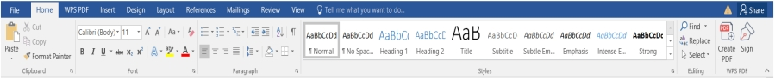

The default tab, containing groups for clipboard functions (copy, cut, paste), font formatting, paragraph styles, and editing tools like find and replace.

* **Insert Tab:**



Allows you to add content to your document, such as pages, tables, illustrations, links, headers, footers, and symbols.

* **Design Tab:**



Used for applying document themes, colors, and page backgrounds to create a consistent look and feel.

* **Page Layout Tab:**



Controls the overall appearance of the page, including margins, orientation, size, columns, and breaks.

* **References Tab:**



Contains tools for academic and professional documents, such as creating a table of contents, adding citations, and managing indexes.

* **Mailings Tab:**



Used for mail merge functions to create personalized documents like letters or emails for a list of recipients.

* **Review Tab:**



Facilitates collaboration with features like spelling and grammar check, track changes, and comments.

* **View Tab:**



Lets you switch between different document views (like Print Layout or Read Mode), adjust the zoom level, and show or hide rulers and gridlines.

**In conclusion:**

Microsoft Word is a powerful and versatile word processing program for creating, editing, and formatting text-based documents, and its advanced features make it an essential tool for individuals and organizations.

**Course Instructor Sign.**

**Lab Instructor Sign.**

**Date**

Student’s ID: **Laboratory Exercise No: 3** Student’s Name:

**Objective:** Create a report using MS word 2013.

**Goal:** In this lab, students will practical familiarity to write a report using M.S word 2013.

## Required Equipment:

### PC.

* + 1. MS word 2013

## Theory:

**Steps to write a report in M.S Word 2013.**

1. Open Word document in M.S Word 2013 as mentioned in previous lab. exercise.
2. Add Title Page (Cover Page). (Go to ‘INSERT’ tab and select ‘Cover Page’ from command group ‘Pages’). Select any desired Cover Page template from preview window.

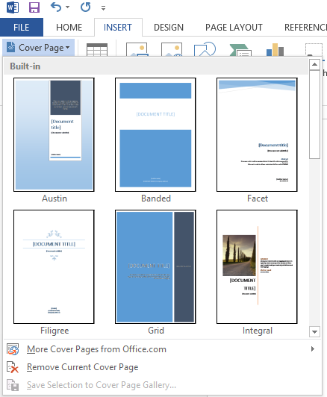

1. Simply type Copyright, Abstract, Acknowledgement, Preface, Table of contents, Introduction. (Using rich text format). (Separated by line-feed).
2. Select all these six and apply ‘Heading 1’ from Style command group (these fields will show now with blue color after applying heading). Separate each these with page break from Pages command group in INSERT tab.
3. Insert table of Contents from REFERENCES tab (Automatic table of Contents). A table of contents will be generated which will show all contents with page numbers automatically.

## How to insert multi-level list

If there is a sub heading in report, following are steps to insert Multi-level list.

1. Right click on the heading which is meant to be sub heading in report. Select ‘Multilevel’ list from Paragraph command group in Home tab.
2. Choose ‘Define New Multilevel List’. It will bring (pop up) a window, showing different options to be applied, as shown below.

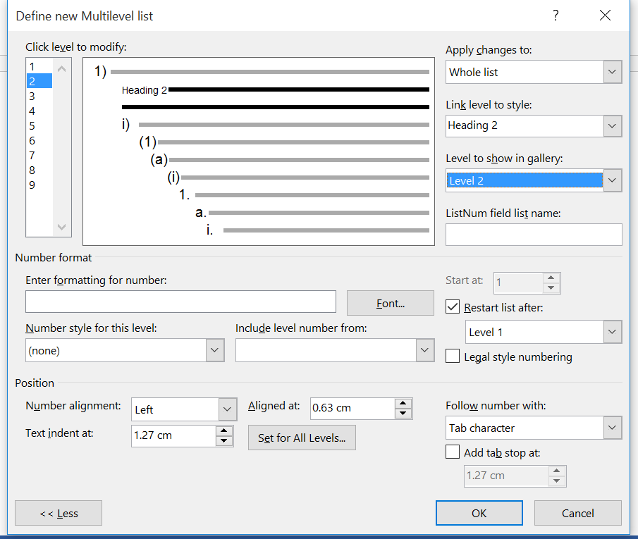

1. ‘Click level to modify’ is the level to which extend sub heading to be incorporated in word document. Choose 2.
2. Choose heading style you have chosen from ‘Style’ command group for current heading from ‘Link level to style’.
3. Choose the level of heading which is meant to be displayed in ‘Style’ command group from ‘Level to show in gallery’.
4. Remove any number from ‘Entering formatting for number’ and select ‘none’ from ‘Number style for this level’ if you do not want to list any number listing from this heading. (Appropriate Number style can be selected if numbers meant to be displayed along with heading like Chapter Numbers).
5. Select ‘OK’.

This will make any selected heading sub heading for word document. But it will not show as sub heading in table of content until it is updated.

## How to update Table of Contents

1. Left click on table of contents, it will display options on the top left corner to update. Left click ‘Update Table’.
2. ‘Update Table of Contents’ window will appear. Choose ‘update entire table’.

This will update table of contents and sub heading will show as sub heading here as well as shown Hardware heading in fig below.

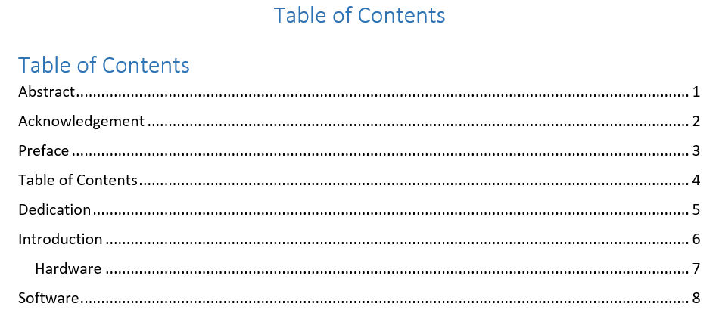

## How to display page numbers in document

* 1. Click on INSERT tab and choose ‘Page Number’ from ‘Header & Footer’ command group.
  2. It will display different options to display page numbers for example ‘top of page’ bottom of page’. If top of page is selected, page numbers will be displayed in header and if bottom of page is selected, page numbers will be displayed in footer.
  3. ‘Format Page Numbers’ is useful to set the way and style page numbers are meant to be displayed.

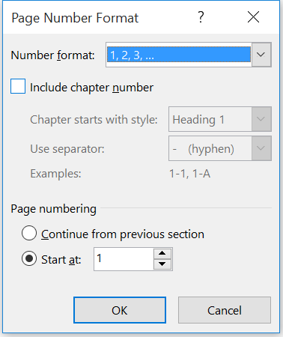

## How to insert Section Breaks in document

1. Select ‘Page Layout’ tab and look for ‘Breaks’ command in ‘Page Setup” command group.
2. Select ‘Next Page’ in ‘Section Breaks’.
3. This will make a different Section start from next page. This will be shown in header or footer as shown below.

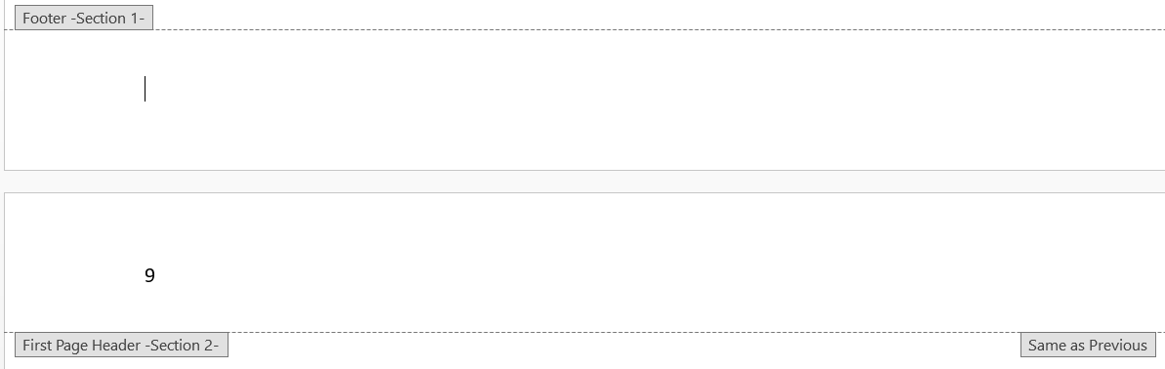

Section Breaks are useful if different page number styles are needed to display in same document. For example if Roman number style is needed to incorporate from Abstract to Preface, it can be dedicated as a different section.

### LAB TASK

## Q) Write a report on any topic with proper formatting utilizing MS Word 2013.

# ITC LAB TASK-03 (Report)

* Margin alignment
* Cover page
* Header
* Footer
* Table of Content

# COVER PAGE:

A cover page in MS Word is a professional, formatted first page that introduces your document with elements like the title, author, images, and company logo. It serves to make your document more appealing and helps readers understand its purpose and context right away. Word provides a gallery of per-designed templates for easy creation, and you can also customize your own.

# KEY FUNCTIONS OF A COVER PAGE:

## Identifies the document:

It clearly states the title of the document and the name of the author or creator.

## Enhances professionalism:

It adds a polished and professional look to reports, papers, or other formal documents.

## Adds context:

It can include important details like the course name, instructor, and date for academic papers, or a company logo for business documents.

## Makes a good first impression:

It is the first thing a reader sees, so a well-designed cover page can make a positive and attractive introduction to your content.

The Impact of Social Media on Students

How Social Media Affects Mental Health

Negative Effects of Social Media

Table of Contents

Q. Explore MS word environment further and also familiar with tabs other than HOME. 11

ITC LAB TASK 01-02 11

Insert multi-level list 15

Table of Contents 16

LAB TASK 17

Q) Write a report on any topic with proper formatting utilizing MS Word 2013. 17

ITC LAB TASK-03 (Report) 18

COVER PAGE: 19

KEY FUNCTIONS OF A COVER PAGE: 19

Steps to produce Mail Merge: 30

Steps to produce Mail Merge: 31

LAB TASK 34

Q) Develop a work sheet of 10 students in a college with the number of days 34

ITC LAB TASK 05 35

To group rows or columns: 38

To hide and show groups: 39

LAB TASK 39

Q) Every student will develop a mark sheet with his/her details 39

Creating a Database: 41

LAB TASK 44

Q) Create any database with 10 fields maximum in MS Access 2013 44

Presentation PowerPoint 2013: 46

Lab 06 Task: 49

Q: Make a presentation in power point on any suitable topic. 49

Difference between Tables and Form: 51

create a form: 51

Laboratory Experiment 10 52

Student’s task: 54

Laboratory Experiment 11 57

HTML Login , Information Page: 57

Laboratory Experiment 12 61

concepts of table layout designing: 62

#### 1. Introduction

In the digital age, social media has become an inseparable part of students’ daily lives. While it offers opportunities for communication and learning, excessive use can impact mental well-being.

#### 2. What Is Social Media?

Social media refers to online platforms such as Instagram, Facebook, Ticktock, and X (formerly Twitter) that allow users to share content, communicate, and build communities.

#### 3. How Social Media Affects Mental Health

Constant exposure to others’ lives can create pressure, comparison, and sometimes lead to anxiety or depression among students.

#### 4. Positive Effects of Social Media

* Builds social connections
* Provides learning opportunities
* Enhances creativity and self-expression

#### 5. Negative Effects of Social Media

* Increases stress and anxiety
* Leads to procrastination
* Reduces sleep quality
* Promotes unrealistic comparisons

#### 6. Strategies for Healthy Social Media Use

#### 

6.1 Setting Time Limits

Students should monitor their daily screen time using built-in app timers.

6.2 Following Positive Accounts

Engaging with educational and motivational content improves mental wellness.

6.3 Taking Digital Detox

Occasionally logging off helps refresh the mind and regain focus.

#### 7. Real-Life Case Studies

A survey by Stanford University found that students who practiced digital detox reported 30% better concentration during exams.

#### 8. Conclusion

Social media can be both a blessing and a curse. With awareness and balance, students can enjoy its benefits without compromising mental health.

Student’s ID: **Laboratory Exercise No: 4** Student’s Name:

**Objective:** To familiar with the environment of MS Excel 2013.

**Goal:** In this lab, students will practical familiarity with MS Excel and produce graph of a sine wave function.

## Required Equipment:

### PC.

1. MS Excel 2013

## Introduction:

Excel 2013 is a spreadsheet program that allows you to store, organize, and analyze information. While you may believe Excel is only used by certain people to process complicated data, anyone can learn how to take advantage of the program's powerful features. Whether you're keeping a budget, organizing a training log, or creating an invoice, Excel makes it easy to work with different types of data.

## Getting to know Excel 2013

Excel 2013 is similar to Excel 2010. If you've previously used Excel 2010, Excel 2013 should feel familiar. If you are new to Excel or have more experience with older versions, you should first take some time to become familiar with the Excel 2013 interface.

## The Excel interface

When you open Excel 2013 for the first time, the Excel Start Screen will appear. From here, you'll be able to create a new workbook, choose a template, and access your recently edited workbooks.

From the Excel Start Screen, locate and select Blank workbook to access the Excel interface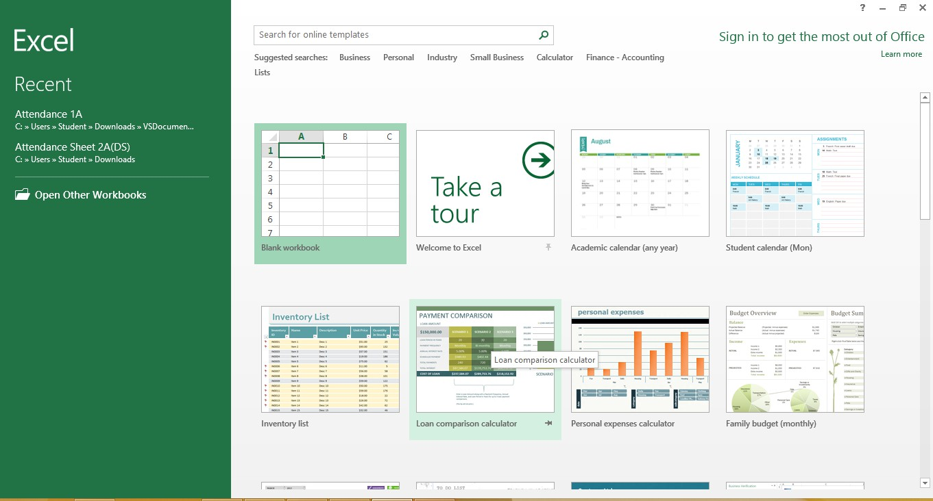

Click the buttons in the interactive below to become familiar with the Excel 2013 interface.

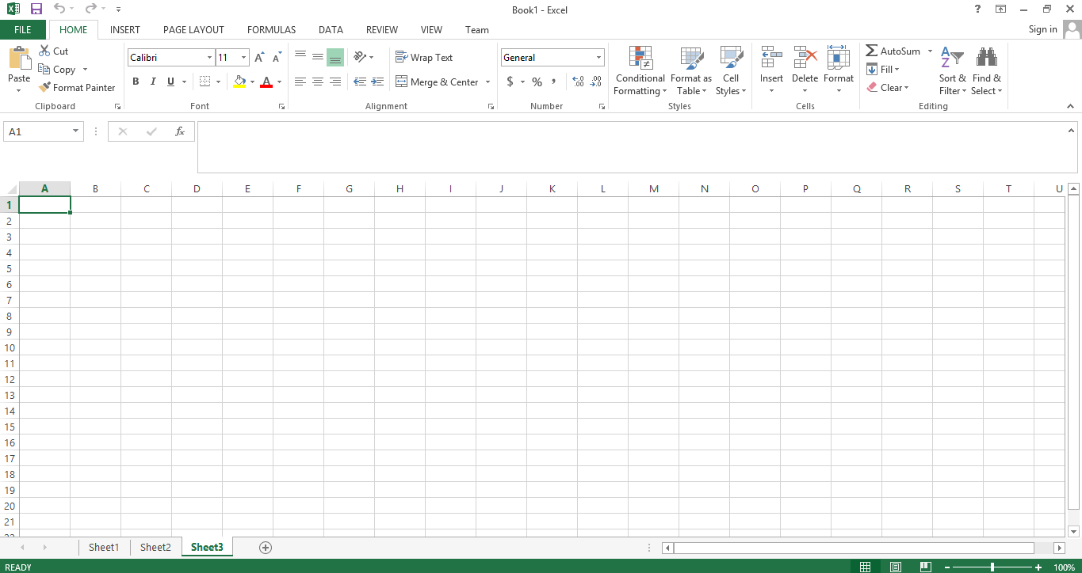

Most commands in Ribbon tabs in MS Excel 2013 are similar to MS Word 2013, students need to explore these commands and function in during their laboratory exercise.

## How to generate function of sine wave and display its graph:

1. Select column A and select ‘Fill’ command from command group ‘Editing’ in HOME tab.
2. Write 0 in ‘A1’ cell.
3. Select ‘Series’ in drop down menu. A window contain label ‘Series’ will pop up.
4. Select following parameters as shown in fig below to generate a series of number from ‘1 to 360’ equally distributed (linear function). Column ‘A’ contain angles in degree from 0° to 360°.
5. 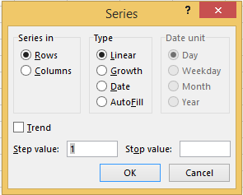Select cell ‘B1’ and write ‘=’. This will automatically initialize formula. This is the method to plug a formula in any cell in MS Excel 2013.
6. Now write sin (A1) and press ‘Enter’ key. This will calculate sin function value of number contained by A1 cell (which is 0 so sin (0) is 0).
7. Now place cursor to the bottom right corner of cell ‘B1’. Cursor shape will turn will turn into cross sign as shown fig below.
8. 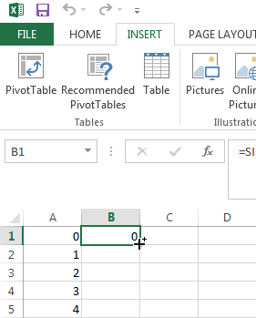Double click now and sin function will be applied to whole ‘B’ column. (By default, excel trigonometric function take angle as argument in radian. To convert angle from degree to radian in sin function argument we select cell ‘B1’

and edit sin function as =SIN(RADIANS(A1)) and press Enter. Repeat steps 7 and 8).

1. Now we have degree in column ‘A’ and calculated relevant sin function outcome in column ‘B’.
2. Select ‘Line Chart’ (2D) from ‘Charts’ command group in ‘INSERT’ tab. A blank chart window will appear on Excel work sheet.
3. Right click on blank chart area and select ‘Select Data’.
4. Write ‘=Sheet1!$B$1:$B$361’ in ‘Chart Data Range’. This will select the data from cell B1 to B361 of work sheet No. 1 and select ‘OK’.
5. ‘Select data Source’ window will look like fig below.

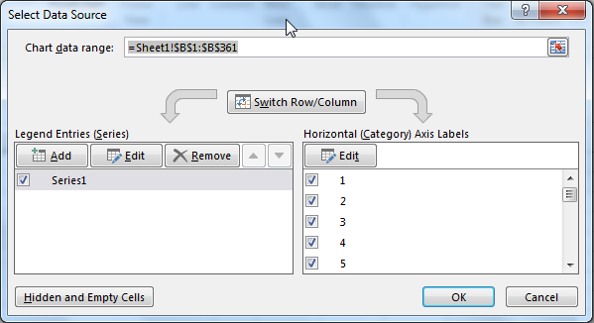

1. Note that on ‘Legend Entries’ Series1 is mentioned and in ‘Horizontal Category Axis Labels’ numbers from 1 to 361 is mentioned which means Series1 contain data (Sin (0°) to Sin (360°)) from row 1 to 361. We need to edit data plotted on Horizontal Axis (x-axis), 0° to 360° so we will have to edit ‘Horizontal (Category) Axis Labels’.
2. Click ‘Edit’ in Horizontal Axis label and write ‘=Sheet1!$A$1:$A$361’ and select ‘OK’. (Notice ‘Horizontal (Category) Axis Labels’ shows correct data (0° to 360°)).
3. Now finally from ‘Chart Tools’ tab (This tab is optional tab and will only enable when chart is selected), click ‘Add Chart Element’. From ‘Axis’ enable both ‘Primary Horizontal’ & ‘Primary Vertical’ axes.
4. Choose appropriate Axes titles, chart label and legend from ‘Add Chart Element’ options to show graph like fig shown below.

Student’s ID: **Laboratory Exercise No: 5** Student’s Name:

**Objective:** To familiarise with the concept of Mail Merge.

**Goal:** In this lab, students will develop practical familiarity with Mail Merge concept.

## Required Equipment:

### PC.

1. MS Word 2013.
2. MS Excel 2013.

## Introduction:

Mail Merge is a handy tool that enable us to produce multiple letters, labels, envelopes, name tags, and more using information stored in a list, database, or spreadsheet. When performing a Mail Merge, students will need a Word document (it can be started with an existing one or create a new one) and a recipient list, which is typically an Excel workbook.

## Steps to produce Mail Merge:

Consider a scenario where an aptitude test has been conducted in an institute for induction of batch fall 2015. Type Excel workbook as shown.

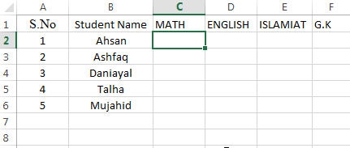

1. Select Cell ‘C2’ and write ‘=rand() ‘ and press Enter. This will produce a random number which is greater than 0 but less than 1. So write ‘=RAND()*100’ and press Enter. This will produce a random number which is greater than 1 and less than 100 in fraction. To round off random numbers to ‘n’ significant figure, ‘round()’ command is used. So write ‘=round((RAND()*100);0)’. This will produce a random integer number which is greater than 1 and less than 100.
2. Place cursor on the bottom right corner of cell ‘C2’where a small square box shows, cursor shape will turn as + (cross sign). Double click on the square box will apply above mentioned step from ‘C2’ to ‘C6’. To prevent data from any change, copy marks from cell ‘C2’ to ‘C6’ and select ‘Values’ from Paste Options.
3. Similarly Select Cell ‘D2’ and write ‘=RANDBETWEEN(1,100) ‘ and press Enter. This will produce a random integer number which is greater than 1 but less than 100.
4. Repeat Step 2 for cells ‘D2’ to ‘D6’.
5. Fill complete sheet with the commands described above.
6. Add ‘Average’ and ‘Total’ columns in ‘G’ and ‘H’ columns respectively. Select ‘G2’ cell and write ‘=AVERAGE(C2:F2)’ which will calculate average marks of student named Ahsan in all subjects.
7. Repeat step 2 for cell no ‘G2’ to ‘G6’.
8. Write ‘=SUM(C2:F2)’ in cell ‘H2’ and press Enter. This command will calculate total number of student named Ahsan.

Finally workbook will look like shown below;

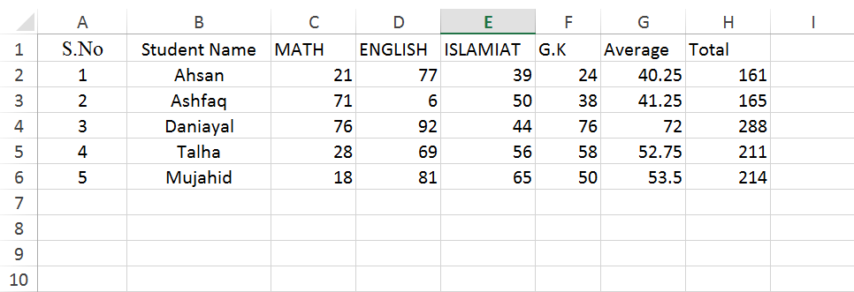

1. Save this work sheet and close excel document.

## Steps to produce Mail Merge:

1. Open a blank MS Word 2013 document and type as shown below.

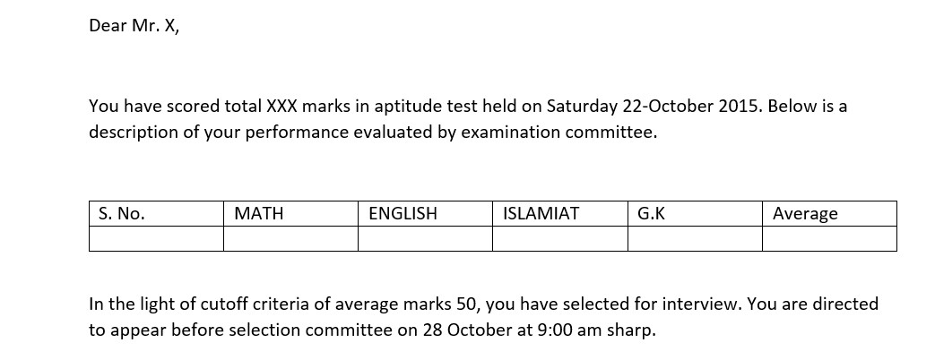

1. Select ‘Start Mail Merge’ from ‘Start Mail Merge’ command group in ‘MAILINGS’ tab and select ‘Letters’.
2. Select ‘Select Recipients’ from same command group and select ‘Use an Existing List’. Browse through your PC and select MS Excel worksheet which was developed in previous steps.
3. ‘Select Window’ will pop up. Click ‘OK’.
4. This will import data from worksheet to MS Word 3013. (Notice how other commands and options in ‘MAILINGS’ tab are enabled.
5. To check if all workbook data has been imported, select ‘Edit Recipient List’. From fig below, It can be clearly seen that students data has been successfully imported for mail merge.

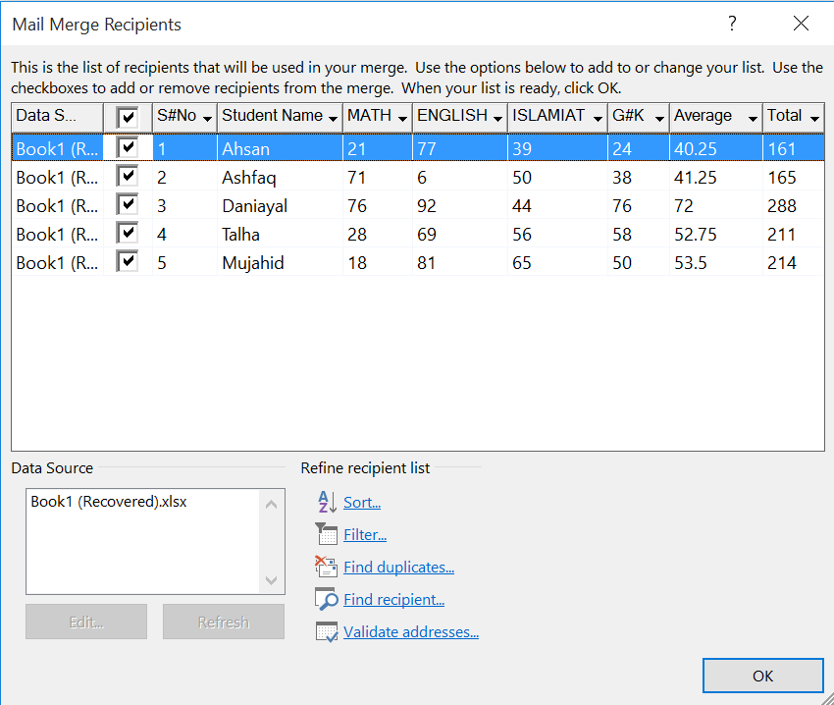

1. As the passing criteria was average 50 marks, this list need to be filter out names of candidate who are failed in this test. Select ‘Filter’ command listed under ‘Refine recipient list’. A ‘Filter and Sort’ window will appear.
2. Select ‘Average’ from fields, ‘Greater than or equal’ and write ‘50’ in ‘Compare to’ field as shown in fig. below. This will filter out those candidate, whose average marks is below 50.

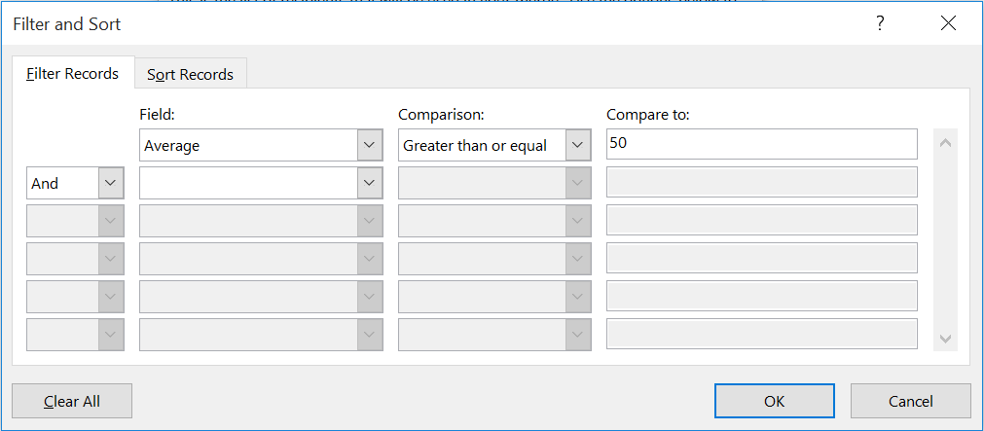

1. Merge fields need to be inserted now. Select ‘X’ next to Mr. and select ‘Insert Merge Field’ from ‘Write and Insert Fields’. There are all ‘Merge Fields’ present there which were column header of MS Excel 2013. Select ‘Student Name’ field.
2. Select ‘XXX’ next to total and select ‘Total’ field and insert it.
3. Similiarly place cursor below table fields ‘S.No’ , ‘MATH’, ‘ENGLISH’, ‘ISLAMIAT’, ‘G.K’ and ‘Average’ and insert fields ‘SNO’, ‘MATH’, ‘ENGLISH’, ‘ISLAMIAT’, ‘GK’ and ‘Average’ respectively as shown below.

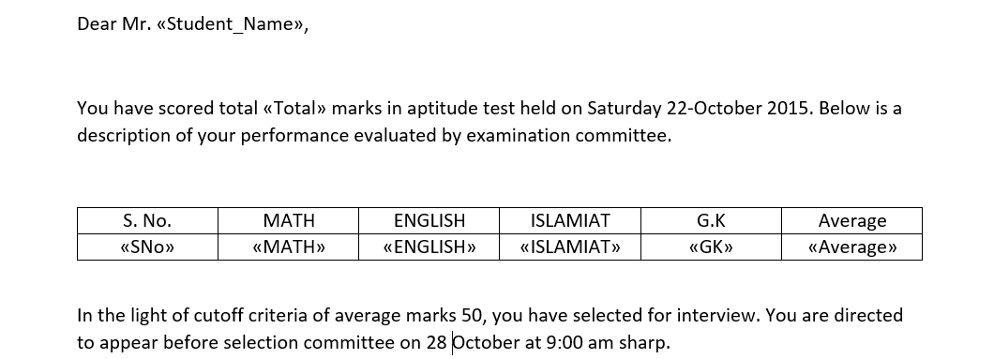

1. Merge fields are enclosed with << >>. Select ‘Preview Results’. This will show the preview of final document produced after mail merge is finished. ‘2’ in ‘Preview Results’ command group represent second candidate.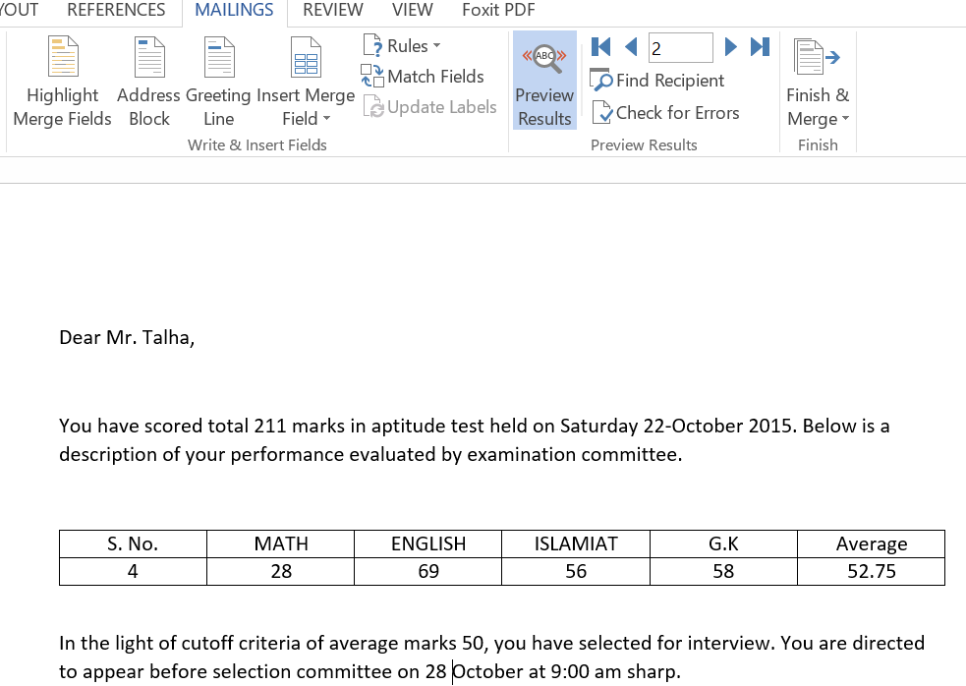
2. Select ‘Finish & Merge’ from ‘Finish’ command group. This will provide three options to be selected as shown in fig. below. Take desired action.

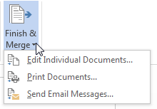

### LAB TASK

## Q) Develop a work sheet of 10 students in a college with the number of days they had been absent from college. Develop a mail merge to send letters to their parents/guardians if any of them had been absent more than 3 days.

**Course Instructor Sign.**

**Lab Instructor Sign.**

**Date**

# ITC LAB TASK 05

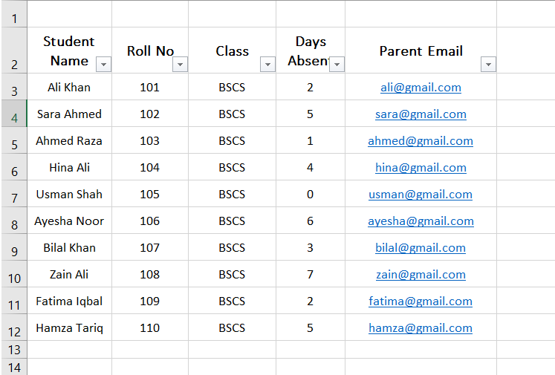Subject: Student Attendance Notice

Dear Parent/Guardian,

This is to inform you that your child Hamza Tariq

(Roll No:110 ) has been absent for 5 days.

Please ensure regular attendance in college.

Regards,

College Administration

Student’s ID: **Laboratory Exercise No: 6** Student’s Name:

**Objective:** To familiar with the implementation of conditional statement IF in MS Excel 2013.

**Goal:** In this lab, students will learn how to implement nested IF statement to make first semester mark sheet. .

## Required Equipment:

### PC.

1. MS Excel 2013.

## Introduction:

In computer science, conditional statements is a logical expression which computes and produce certain results (provided by User) based on a certain test condition. A conditional statement in Excel is a formula that makes a logical test of data using the IF function. It essentially allows a computer User to create a basic logical argument of “If (this), then (that).”

## Syntax:

*IF (logical test, Value if true, Value if false)*

“Value if true” and “Value if false” will be enclosed in double quote “ if it is alphabetic character.

## Utilizing IF Statement:

1. Type MS Excel 2013 work sheet as shown below.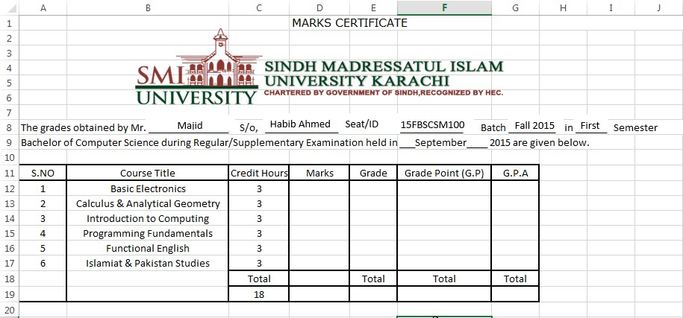
2. 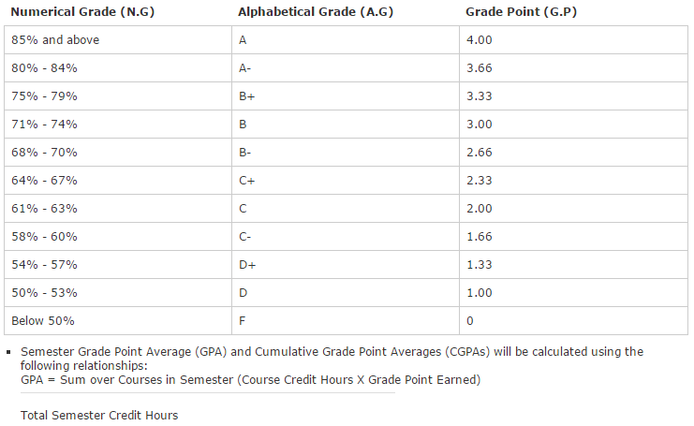‘Course Grading System’ according to smiu website is shown below.
3. Either write Mark manually or generate it through ‘randbetween’ function.
4. Select first subject Grade cell (which is E12 as shown above) and write;

=if(D12>=85,"A",if(D12>=84,"A-",if(D12>=79,"B+",if(D12>=74,"B",

if(D12>=70,"B-",if(D12>=67,"C+",if(D12>=63,"C",if(D12>=60,"C-",

if(D12>=57,"D+",if(D12>=53,"D","F"))))))))))

1. Above command check if Marks in D12 cell are equal or greater than 85, if this is true statement, A will be displayed in E12 cell else next test condition will be evaluated. If marks does not match with any of the test condition, it will display last alphabetical value

(F). This will evaluate Grade. Double click on small square of E12 cell to apply this statement to each subject Grade with relevant Marks.

1. Select First Subject G.P cell (which is F12 as shown above) and write;

=IF(E12="A",4,IF(E12="A-",3.66,IF(E12="B+",3.33,IF(E12="B",3,

IF(E12="B-",2.66,IF(E12="C+",2.33,IF(E12="C",2,IF(E12="C-",1.66,

IF(E12="D+",1.33,IF(E12="D",1,0))))))))))

1. Above command check if Grade in E12 cell is same as grade A , if this is true statement, 4 will be displayed in F12 cell else next test condition will be evaluated. If grade does not match with any of the test condition, it will display last numerical value (0). This will evaluate G.P. Double click on small square of F12 cell to apply this statement to each subject G.P with relevant grade.
2. Finally the spread sheet will look like as shown below:

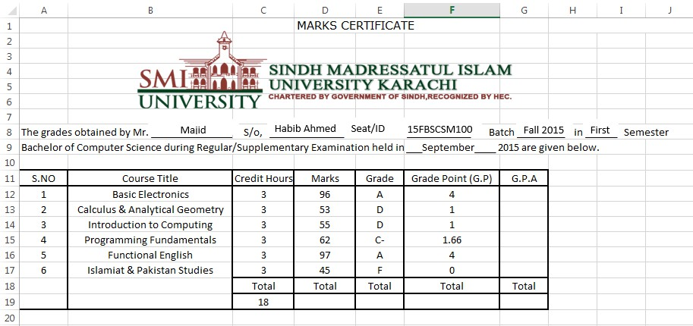

## Groups:

Worksheets with a lot of content can sometimes feel overwhelming and even become difficult to read. Fortunately, Excel can organize data in **groups**, allowing us to easily **show** and **hide** different sections of worksheet.

## To group rows or columns:

* 1. Select the **rows** or **columns** which are needed to be in group. In this example, we'll select columns **A**, to **G**.
  2. Select the **Data** tab on the **Ribbon**, then click the **Group** command.
  3. The selected rows or columns will be **grouped**. In our example, columns from **A**, to **G**

are grouped together.

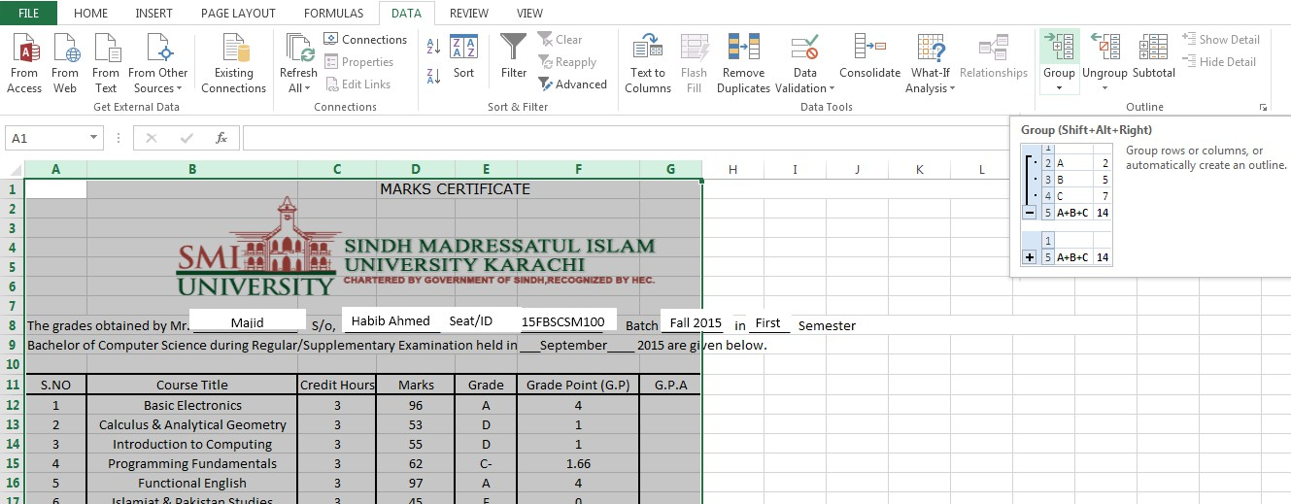

* 1. To **ungroup** data, select the grouped rows or columns, then click the **Ungroup** command.

## To hide and show groups:



1. 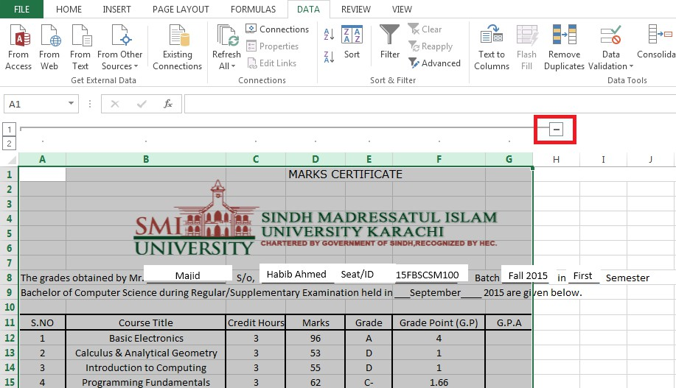To hide a group, click the **Hide Detail** button .
2. The group will be **hidden**. To show a hidden group, click the **Show Detail** button

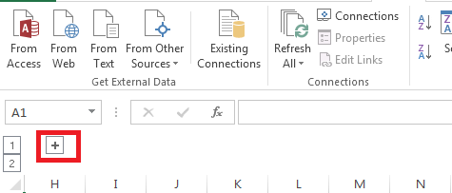

### LAB TASK



## Q) Every student will develop a mark sheet with his/her details as mentioned in this laboratory exercise. Add one column on the right of G.P, designate it as ‘Sum over Course’ header. This column will contain the produce of G.P and Credit hour earn for each course. In the last calculate total G.P.A by formula

## 𝐺. 𝑃. 𝐴 =

## 𝑇𝑜𝑡𝑎𝑙 𝑆𝑢𝑚 𝑜𝑣𝑒𝑟 𝑐𝑜𝑢𝑟𝑠𝑒𝑠 𝑖𝑛 𝑆𝑒𝑚𝑒𝑠𝑡𝑒𝑟

## 𝑇𝑜𝑡𝑎𝑙 𝑆𝑒𝑚𝑒𝑠𝑡𝑒𝑟 𝐶𝑟𝑒𝑑𝑖𝑡 𝐻𝑜𝑢𝑟𝑠

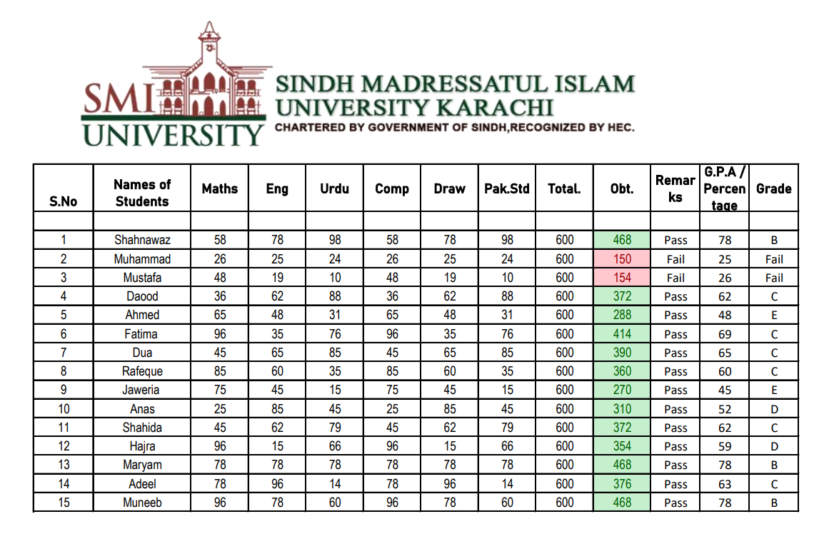

**Course Instructor Sign.**

**Lab Instructor Sign.**

**Date**

Student’s ID: **Laboratory Exercise No: 7** Student’s Name:

**Objective:** To familiar with the environment of MS Access 2013.

**Goal:** In this lab, students will learn how to work with MS Access 2013 and how to import its data in Excel 2013.

## Required Equipment:

### PC.

1. MS Excel 2013.
2. MS Access 2013.

## Introduction:

The term database describes a collection of data organized in a manner that allows access, retrieval, and use of that data. Microsoft Access 2013, usually referred to as simply Access, is a database management system. A database management system is software that allows us to use a computer to create a database; add, change, and delete data in the database.

## Creating a Database:

1. Start with ‘Blank Desktop Database’ from template gallery when MS Access 2013 starts. It will require user to input ‘file name’ and location where this database will be saved. Select ‘Create’ when it is done.
2. This will create a default table name as ‘Table 1’. It will reveal that table grid is not created like in MS Excel.
3. Delete this table from left pan window and Go to the ‘Create’ tab and select ‘Table Design’ from ‘Tables’ command group.
4. A new table will be created and this give us flexibility to design customized spread sheet as shown below.
5. Unlike MS Excel spread sheet where we used to write any alphanumeric data anywhere in cell, we will have to mention in Database that which type of data will be recorded in Database.
6. The columns in the tables are called fields. A ‘field’ contains a specific piece of information within a record. A field which is unique, i-e No piece of information in that field will completely identical to any other field. Such field is called ‘Unique Identifier’ or ‘Primary Key’. Every field in the Access is a record. If user will not recognize the ‘Primary Key’ himself, Access will assign any record as ‘Primary Key’.

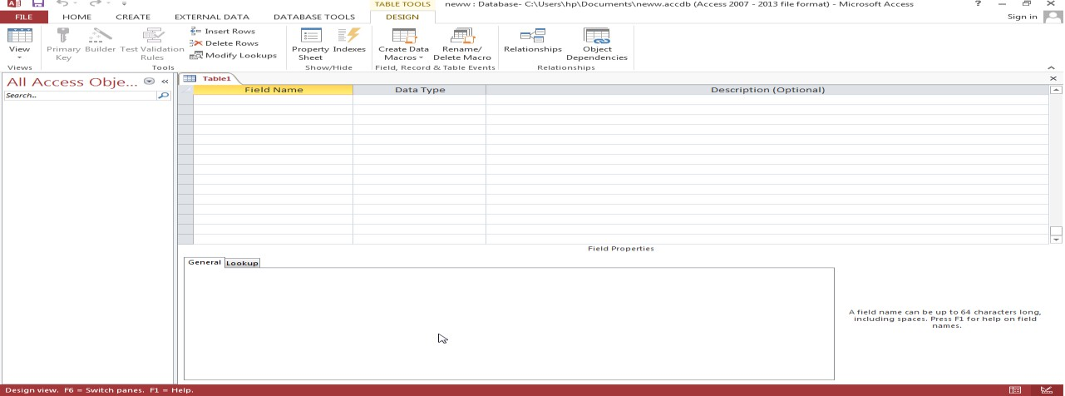

1. Select first entry in ‘Field Name’ and write ‘Student_Roll_No’. To the next column mention its ‘Data Type’ from the given data type list as shown in fig below.

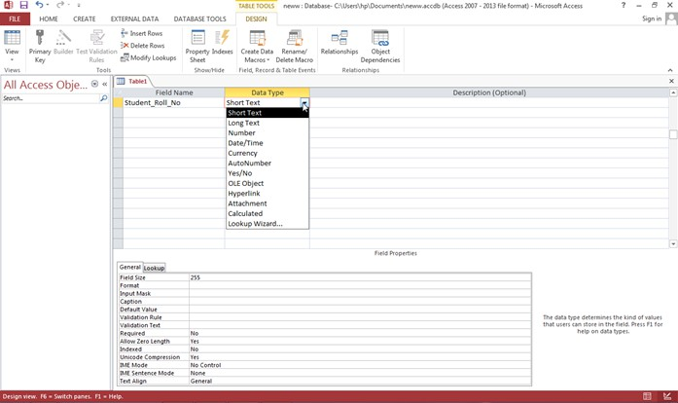

1. Field properties reveals the property of field on the basis of the ‘Data Type’ is chosen.
2. Select ‘Number’ as this field will contain roll numbers of students. Field size will be long integer by default. Field size can be customized by list shown below.

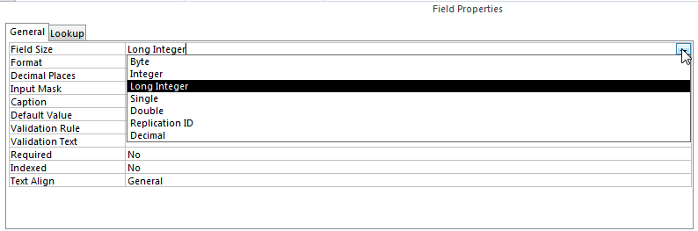

1. One Byte stores a number from 0 to 255. Integer can accommodate number from -32786 to 32767 (2 Byte). Select Integer as the student ID we will record in this exercise, not exceed 32767.
2. Right Click on this field and mark this as ‘Primary Key’. (Two student names can be same but their roll numbers cannot!).
3. Fill the remaining fields as figure shown below.

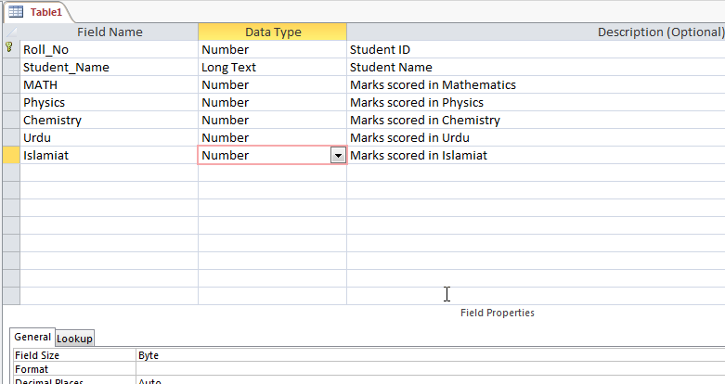

1. Now ‘Save’ this database and close. When this database will be opened, it will let us enter the fields entries we saved as shown below



1. 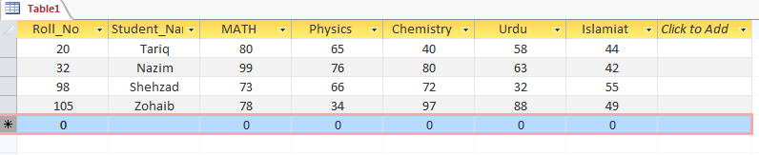Fill all data fields with suitable entries, a sample is given below
2. Save this work and exit from Access 2013.
3. Open a blank Excel document and select ‘from Access’ from ‘Get External Data’ command group in ‘Data’ tab. Browse through the Access Database to select the file and select ‘Open’.
4. An ‘Import Data’ window will pop up which prompts the way this data will be viewed in spread sheet and the location of cell where the first record (Primary Key) will be placed. Select ‘OK”.

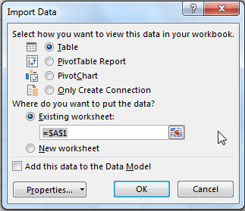

1. Drop down menu on the right of each field allows to sort and filter data.
2. Select all fields and insert column chart. Change graph title to ‘Result’.

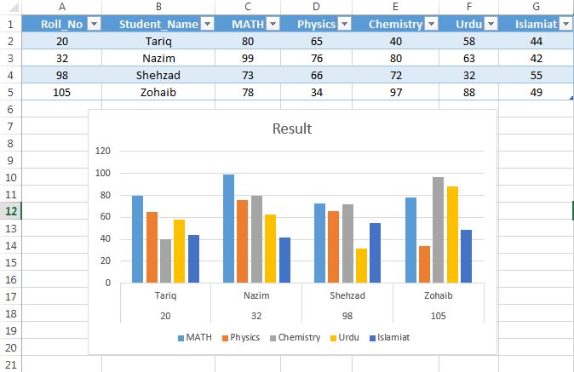

### LAB TASK

## Q) Create any database with 10 fields maximum in MS Access 2013, import its fields in MS Excel and plot a suitable graph (also give brief description of the nature of database fields and graph outcome).

**Course Instructor Sign.**

**Lab Instructor Sign.**

**Date**

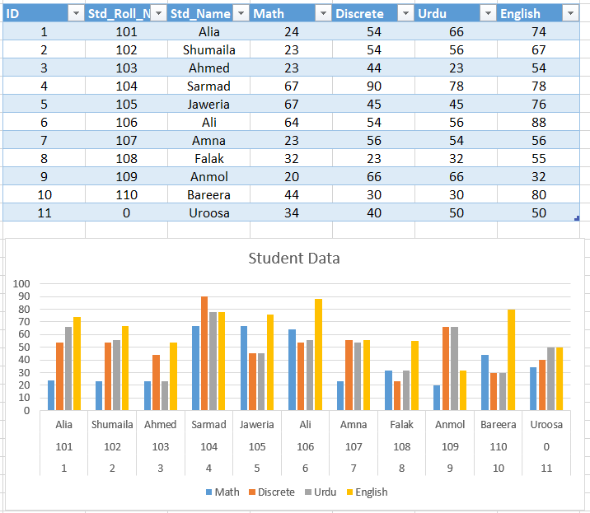

tudent’s ID: **Laboratory Exercise No: 8** Student’s Name:

**Objective:** To familiar with the environment of PowerPoint 2013.

**Goal:** In this lab, students will learn how to work with MS Access 2013 and how to import its data in Excel 2013.

## Required Equipment:

### PC.

1. MS PowerPoint 2013

## Introduction:

Microsoft PowerPoint is a software product used to perform computer-based presentations. There are various circumstances in which a presentation is made such as teaching a class, introducing a product to sell, explaining an organizational structure, etc.

## Some important terminologies:

**Slides:** A slide is an image which is created in PowerPoint.

**Presentation:** Presenting one slide at a time till the end of all slides.

## Getting start with PowerPoint 2013:

1. Start with blank presentation.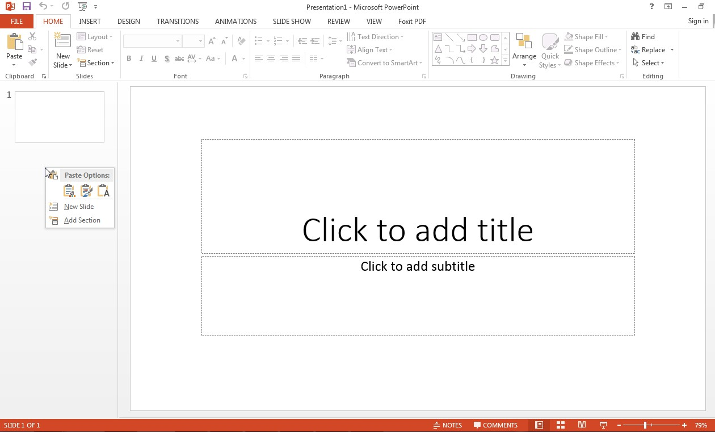
2. Left pane will show all slides including ‘Section’.
3. On right hand current slide, the first slide theme is such as it may contain Title and Subtitle as the beginning of presentation (by default).
4. Next slide can be added by right click on left click and select ‘New Slide’.
5. 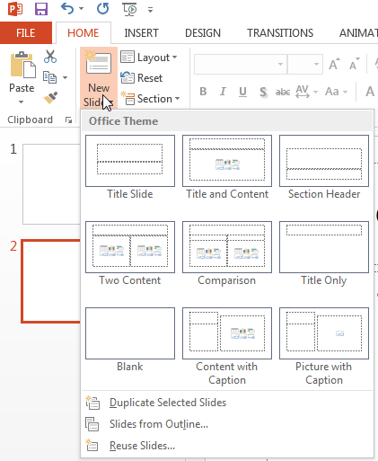There are different sort of slides template provided in ‘New Slides’ option in HOME tab.
6. ‘Transitions’ tab will provide different effects during transition (transition is the term used during presentation when one shifts from one slide to another). In ‘Timing’ command tab, there are options to apply with these effects like ‘duration’ (time period during these effects), ‘one mouse click’ (start effects after mouse click’ and ‘sound’ (to play certain sound).

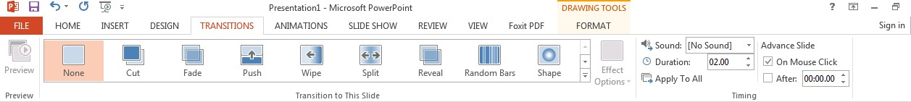

1. ‘Animations’ tab will provide options to adapt certain animation to the slide.
2. ‘Slide Show’ tab have two main command groups which provide different options to start slide show and to ‘Set up’ slide show.
3. There are six icons are displayed in the middle of second slide. Click one of them to insert table, chart, SmartArt Graphic, Pictures (from PC), Online Pictures and Video.

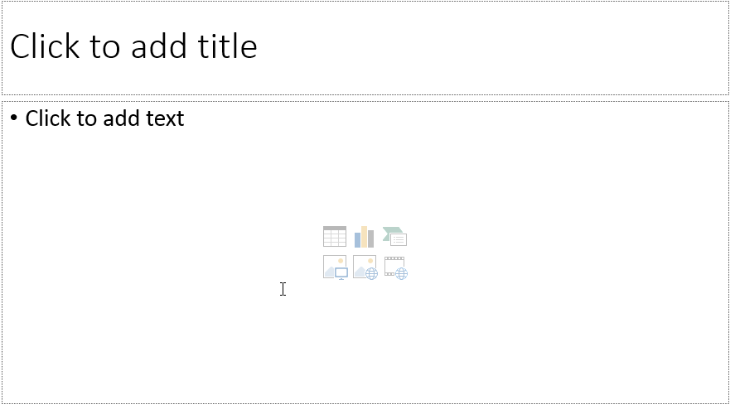

1. HyperLink can be inserted from ‘INSERT’ tab or by short cut key (Ctrl+K). Write any text which will show on foreground in place of true URL (Adress).

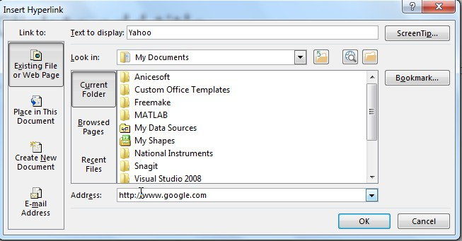

1. Right click on Hyperlink and select ‘Open Hyperlink’ to open or “Edit Hyperlink’ to edit hyperlink.

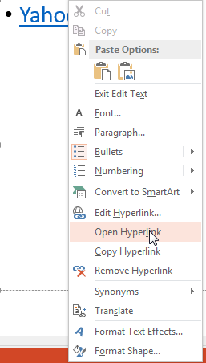

1. When everything is done. Press (F5) or select ‘From Beginning’ from ‘SLIDE SHOW’ tab.

# Lab 06 Task:

## Q: Make a presentation in power point on any suitable topic.

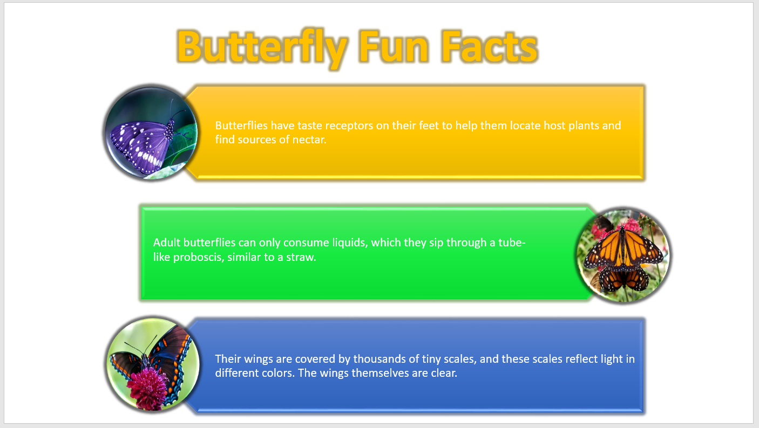



Student’s ID: **Laboratory Exercise No: 9** Student’s Name:

**Objective:** To create a form.

**Goal:** In this lab, students will learn how to create form utilizing MS Access 2013.

## Required Equipment:

### PC.

* 1. MS Access 2013.

## Introduction:

To easily view, enter and change data directly in a table, a form is created. When a form is opened, MS Access retrieves the data from one or more tables and displays it on screen using the layout created by user.

## Difference between Tables and Form:

|  |  |
| --- | --- |
| **Tables** | **Form** |
| Tables display many records at the same  time. | Forum focus on one record at a time. |
| Data cannot be updated from more than one table at the same time. | Forum can display fields from multiple tables. |

**Purposes:**

1. A data entry form can be created to enter data into a table.
2. A custom dialogue box can be created to accept user input and then an action can be taken based on that input.
3. A simple switchboard form can be created to open other forms.

## How to create a form:

Let’s create a table which is used to keep record of books in a library which contains Title, Author Name, and Edition and Publishing year of books.

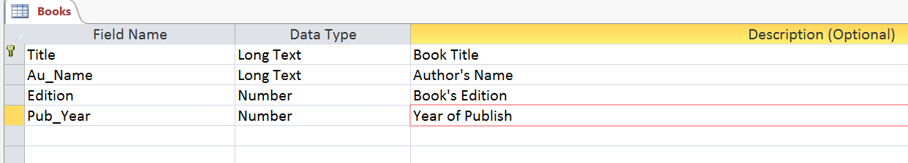

## Click on ‘Forum Design’ from ‘Form’ command group in ‘Create’ tab if you want to create form from scratch (layout will have to be created manually or ‘Form Wizard’ can be used to quickly create basic layout design for form).

# Laboratory Experiment 10

**Objective:** To learn how to create a MS Access database.

**Goals:** Students will be able to understand the basic concept of MS Access database.

## Required Tools / Equipment’s:

### PC

* + MS Access

**Theory**

A **database** is a collection of related information and has several objects such as a table, query, form or report.

A **table** is a grouping of related data organized in fields (columns) and records (rows) on a datasheet. Many tables can be stored in a single database.

A **field** is a column on a datasheet and defines a data type for a set of values in a table. For a Mailing list a table might include fields for first name, last name, address, city, state, zip code, and telephone number.

A **record** in a row on a datasheet and is a set of values defined by fields. In a mailing list table,

each record would contain the data for one person as specified by the intersecting fields.Every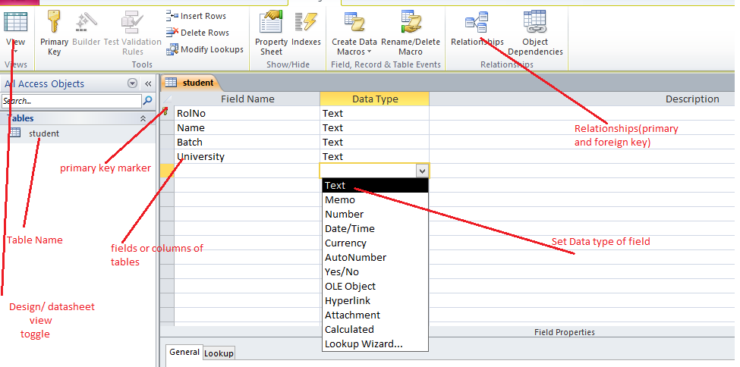 record in a given table has the same fields in the same order

The **Database Window** displays the various objects in an Access database. The default tables

Listing provides links for creating tables and will list all of the tables in the database when they have been added.

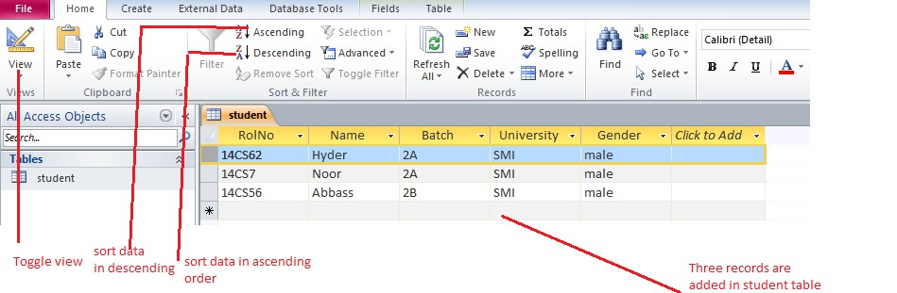

A table is displayed in multiple views. **Design View** is used to define the table initially and to specify the fields it will contain so that the data can be entered.

**Datasheet View** allows you to update, edit, and delete records.

*Create a form by using the Form tool*

You can use the Form tool to create a form with a single mouse-click. When you use this tool, all the fields from the underlying data source are placed on the form. You can start using the new form immediately, or you can modify it in Layout view or Design view to better suit your needs.

**Use the Form tool to create a new form**

1. In the **Navigation Pane**, click the table or query that contains the data you want to see on your form.
2. On the **Create** tab, in the **Forms** group, click **Form**.

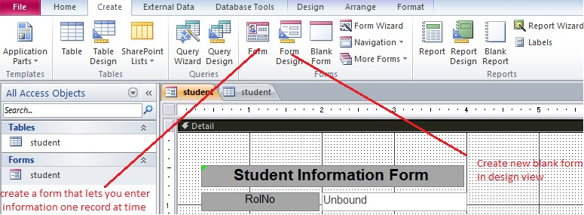

## Student’s task:

**Answer the following questions:**

1. **Create Student Information Table?**

|  |  |
| --- | --- |
| **Field Name** | **Data type** |
| Roll No First Name Last Name Address City  Date of Birth  Gender | Text Text Text Text  Date/ Time Text |

* 1. **Design student information form and insert bio data into student information table?**

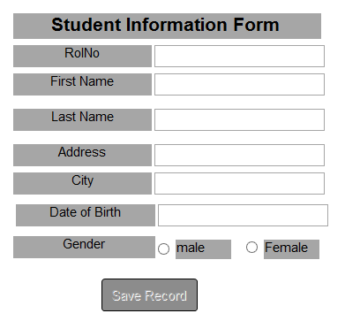

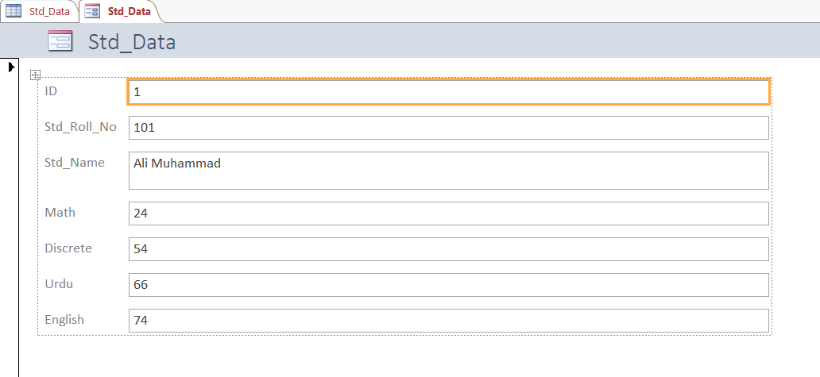

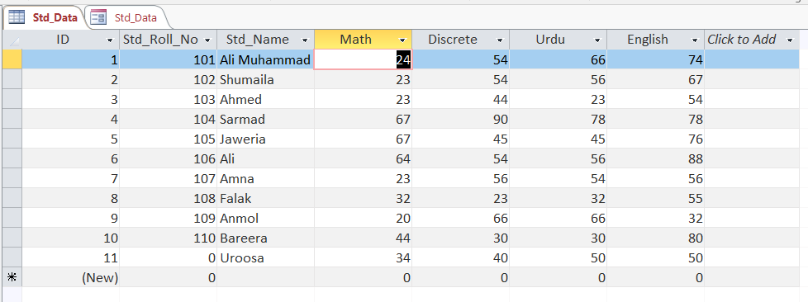

# Laboratory Experiment 11

**Objective:** To understand the basic concepts of web development and HTML designing.

* + - How to use paragraph
    - How to use headings.
    - How to use images in HTML.
    - How to use bullets.

**Goals:** Students will be able to understand Basic Concept of web development and HTML designing.

## Required Tools / Equipment’s:

### PC

* Notepad
* Browser(any)
* Internet

## Theory:

HTML is a markup language for describing web documents (web pages).

* HTML stands for Hyper Text Markup Language
* A markup language is a set of markup tags
* HTML documents are described by HTML tags
* Each HTML tag describes different document content

<html>

<Head>

<title>Title of the document</title>

</head>

<body>

the content of the document

</body>

</html>

**Procedure**

HTML can be edited by using a professional HTML editor like:

* + Adobe Dreamweaver
  + Notepad

However, for learning HTML we recommend a text editor like Notepad (PC) We believe using a simple text editor is a good way to learn HTML.

Follow the 4 steps below to create your first web page with Notepad.

**Step 1**: Open Notepad

To open Notepad in Windows 7:

Click Start (bottom left on your screen).>Click All Programs>Click Accessories. Click Notepad.

**Step 2**: Write your HTML code

**Step 3**: Save the HTML Page

Save the file on your computer.

Select **File > Save as** in the Notepad menu.

You can use either .htm or .html as file extension. There is no difference, it is up to you.

**Step 4**: View HTML Page in Your Browser

Double-click your saved HTML file, and the result will look much like this:

## Student’s task:

**Answer the following questions:**

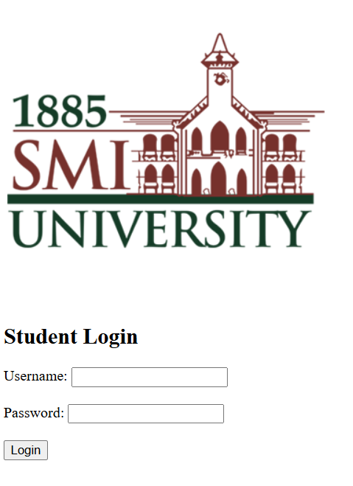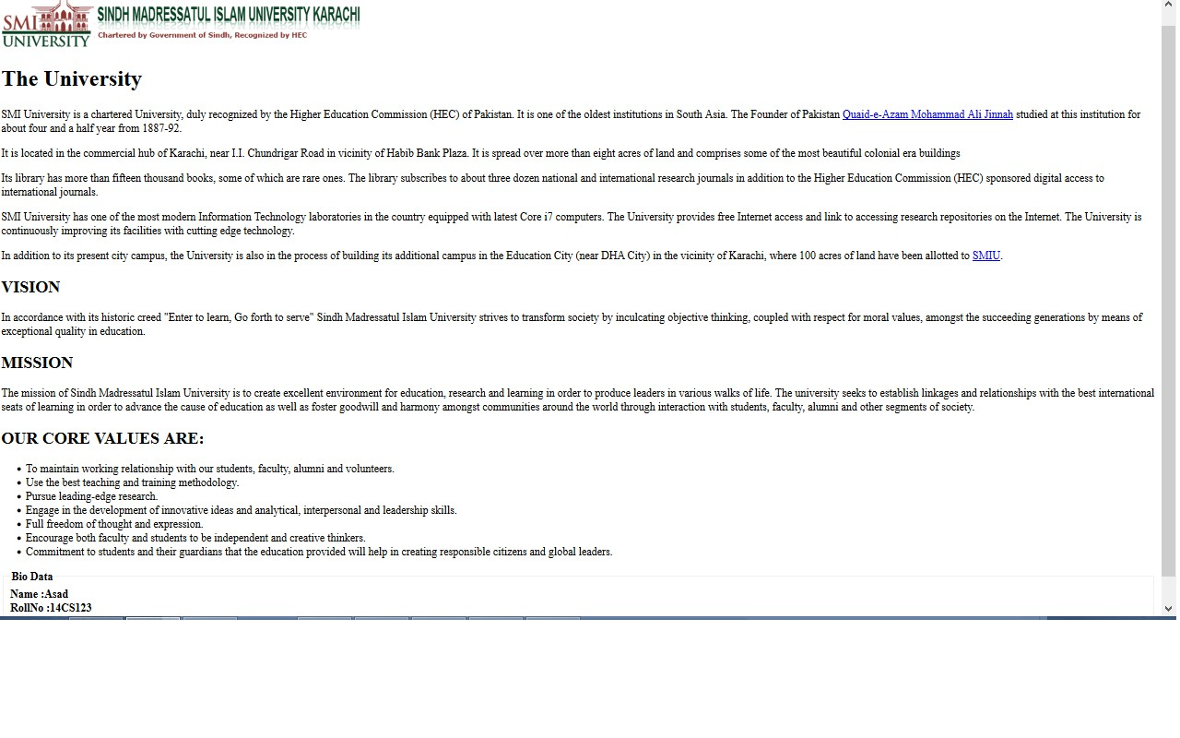**Design SMI University information page?**

**SMI University information page**

<!DOCTYPE html>

<html>

<head>

<title>SMI University</title>

</head>

<body>

<h1>Sindh Madressatul Islam University</h1>

<p>Sindh Madressatul Islam University is a well known public sector university located in Karachi.</p>

<h2>History</h2>

<p>SMI University was established in 1885.</p>

<h3>Faculties</h3>

<ul>

<li>Computer Science</li>

<li>Business Administration</li>

<li>Social Sciences</li>

</ul>

<h4>Programs</h4>

<ol>

<li>BSCS</li>

<li>BBA</li>

<li>BS Mathematics</li>

</ol>

</body>

</html>

**Course Instructor Sign.**

**Lab Instructor Sign.**

**Date**

# Laboratory Experiment 12

**Objective:** To understand the basic concepts of table layout designing.

* + How to use table to control and organize.
  + How to use radio button group in HTML page and how to allow select only one option.
  + How to use select box to choose one or multiple options.
  + How to use Submit and reset button.

1. The **table border** should be “**2**”.
2. Title of page should be your own Student id.
3. Web page must have **SMIU logo** in its **left** and at the **top** as shown.
4. Attendance sheet **interface** and **table** should be **center** aligned.

**Heading** should be

“**Sindh Madressatul Islam University Department of Computer Science**

**1st Semester Fall 2014**

**Course: Programing Fundamental(Lab)**

**Attendance Sheet (CS 3A) – Lab Instructor: Irfan Ali Kandhro**”

**Goals:** Students will be able to understand basic concept of table layout and forms designing.

## Required Tools / Equipment’s:

### PC

* Notepad
* Browser(any)
* Internet

## Theory:

HTML is a markup language for describing web documents (web pages).

**Table**

* Tables are defined with the **<table>** tag.
* Tables are divided into **table rows** with the **<tr>** tag.
* Table rows are divided into **table data** with the **<td>** tag.
* A table row can also be divided into **table headings** with the **<th>** tag.

<table style="width:100%">

<tr>

<td>Jill</td>

<td>Smith</td><td>50</td></tr>

<tr>

<td>Eve</td>

<td>Jackson</td>

<td>94</td>

</tr>

</table>

**HTML Input Types**

|  |  |
| --- | --- |
| **Input type** | **Description** |
| Text | **<input type="text">** defines a one-line input field for **text input**: |
| Radio | **<input type="radio">** defines a **radio button**. |
| Checkbox | **<input type="checkbox">** defines a **checkbox**. |
| Submit | **<input type="submit">** defines a button for **submitting** form input to a **form-handler** |
| Reset | **<input type="reset">** defines a **Reset field**:Clear form data |
| Password | **<input type="password">** defines a **password field**: |
| Dropdown | <select>  <option>1</option  <option>2</option  <option>3</option  </select> |

## Student’s task:

.

## Answer the following questions:

1. **Design SMI University login form in HTML?**

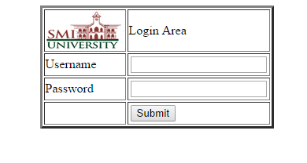

**Code :**

<!DOCTYPE html>

<html>

<head>

<title>SMI Login</title>

</head>

<body>

<h2>Student Login</h2>

<form>

Username: <input type="text"><br><br>

Password: <input type="password"><br><br>

<input type="submit" value="Login">

</form>

</body>

</html>

2.**Design attendance sheet layout in HTML?**

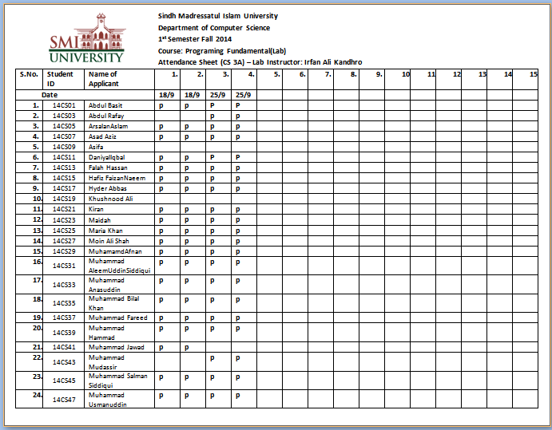

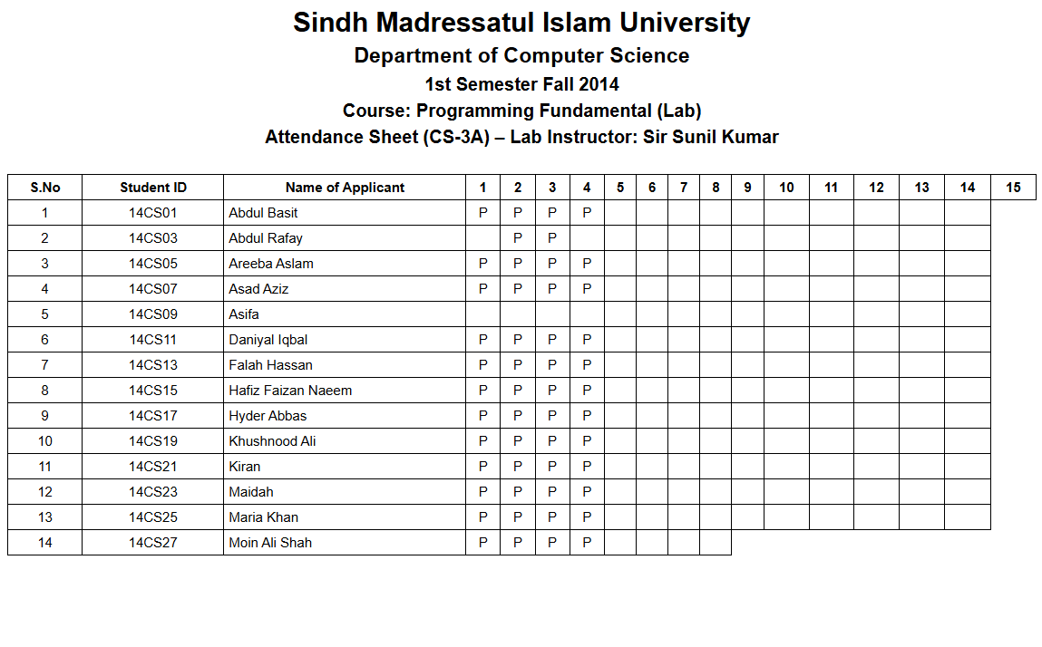

**Code :**

<!DOCTYPE html>

<html>

<head>

    <title>SMI Attendance Sheet</title>

    <style>

        body {

            font-family: Arial, sans-serif;

        }

        h2, h3, h4 {

            text-align: center;

            margin: 5px;

        }

        table {

            width: 100%;

            border-collapse: collapse;

            font-size: 12px;

        }

        th, td {

            border: 1px solid black;

            text-align: center;

            padding: 4px;

        }

        .left {

            text-align: left;

        }

    </style>

</head>

<body>

<h2>Sindh Madressatul Islam University</h2>

<h3>Department of Computer Science</h3>

<h4>1st Semester Fall 2014</h4>

<h4>Course: Programming Fundamental (Lab)</h4>

<h4>Attendance Sheet (CS-3A) – Lab Instructor: Sir Sunil Kumar</h4>

<br>

<table>

    <tr>

        <th>S.No</th>

        <th>Student ID</th>

        <th>Name of Applicant</th>

        <th>1</th><th>2</th><th>3</th><th>4</th><th>5</th>

        <th>6</th><th>7</th><th>8</th><th>9</th><th>10</th>

        <th>11</th><th>12</th><th>13</th><th>14</th><th>15</th>

    </tr>

    <tr><td>1</td><td>14CS01</td><td class="left">Abdul Basit</td><td>P</td><td>P</td><td>P</td><td>P</td><td></td><td></td><td></td><td></td><td></td><td></td><td></td><td></td><td></td><td></td></tr>

    <tr><td>2</td><td>14CS03</td><td class="left">Abdul Rafay</td><td></td><td>P</td><td>P</td><td></td><td></td><td></td><td></td><td></td><td></td><td></td><td></td><td></td><td></td><td></td></tr>

    <tr><td>3</td><td>14CS05</td><td class="left">Areeba Aslam</td><td>P</td><td>P</td><td>P</td><td>P</td><td></td><td></td><td></td><td></td><td></td><td></td><td></td><td></td><td></td><td></td></tr>

    <tr><td>4</td><td>14CS07</td><td class="left">Asad Aziz</td><td>P</td><td>P</td><td>P</td><td>P</td><td></td><td></td><td></td><td></td><td></td><td></td><td></td><td></td><td></td><td></td></tr>

    <tr><td>5</td><td>14CS09</td><td class="left">Asifa</td><td></td><td></td><td></td><td></td><td></td><td></td><td></td><td></td><td></td><td></td><td></td><td></td><td></td><td></td></tr>

    <tr><td>6</td><td>14CS11</td><td class="left">Daniyal Iqbal</td><td>P</td><td>P</td><td>P</td><td>P</td><td></td><td></td><td></td><td></td><td></td><td></td><td></td><td></td><td></td><td></td></tr>

    <tr><td>7</td><td>14CS13</td><td class="left">Falah Hassan</td><td>P</td><td>P</td><td>P</td><td>P</td><td></td><td></td><td></td><td></td><td></td><td></td><td></td><td></td><td></td><td></td></tr>

    <tr><td>8</td><td>14CS15</td><td class="left">Hafiz Faizan Naeem</td><td>P</td><td>P</td><td>P</td><td>P</td><td></td><td></td><td></td><td></td><td></td><td></td><td></td><td></td><td></td><td></td></tr>

    <tr><td>9</td><td>14CS17</td><td class="left">Hyder Abbas</td><td>P</td><td>P</td><td>P</td><td>P</td><td></td><td></td><td></td><td></td><td></td><td></td><td></td><td></td><td></td><td></td></tr>

    <tr><td>10</td><td>14CS19</td><td class="left">Khushnood Ali</td><td>P</td><td>P</td><td>P</td><td>P</td><td></td><td></td><td></td><td></td><td></td><td></td><td></td><td></td><td></td><td></td></tr>

    <tr><td>11</td><td>14CS21</td><td class="left">Kiran</td><td>P</td><td>P</td><td>P</td><td>P</td><td></td><td></td><td></td><td></td><td></td><td></td><td></td><td></td><td></td><td></td></tr>

    <tr><td>12</td><td>14CS23</td><td class="left">Maidah</td><td>P</td><td>P</td><td>P</td><td>P</td><td></td><td></td><td></td><td></td><td></td><td></td><td></td><td></td><td></td><td></td></tr>

    <tr><td>13</td><td>14CS25</td><td class="left">Maria Khan</td><td>P</td><td>P</td><td>P</td><td>P</td><td></td><td></td><td></td><td></td><td></td><td></td><td></td><td></td><td></td><td></td></tr>

    <tr><td>14</td><td>14CS27</td><td class="left">Moin Ali Shah</td><td>P</td><td>P</td><td>P</td><td>P</td><td></td><td></td><td></td><td></td

**Date Lab Instructor Sign. Course Instructor Sign.**